Coding Assessment Portal

In this project we are designing web application where users can signup with the application and then login and can write programs in JAVA or PYTHON and then application will compile and execute code and based on programs correctness application will give grade to the user. While accessing this application we have added following features

1. Disable right click
2. Disable new tab opening
3. Disable screen shots capture

You asked to monitor audio and video and how we can do that as we can monitor using CCTV not only with software’s program

To implement this project we have designed following modules

1. New User Signup: using this module user can signup with the application
2. User Login: using this module user can login to application
3. Python Assessment: using this module user can write python program and then application will compile and run code and based on correctness application will give grade
4. Java Assessment: using this module user can write java program and then application will compile and run code and based on correctness application will give grade
5. Admin Login; admin can login to application using username and password as ‘admin’ and ‘admin’ and after login admin can view all registered user details

For coding assessment you can use test programs given in ‘TestCodeSamples’ folder which is showing below screen

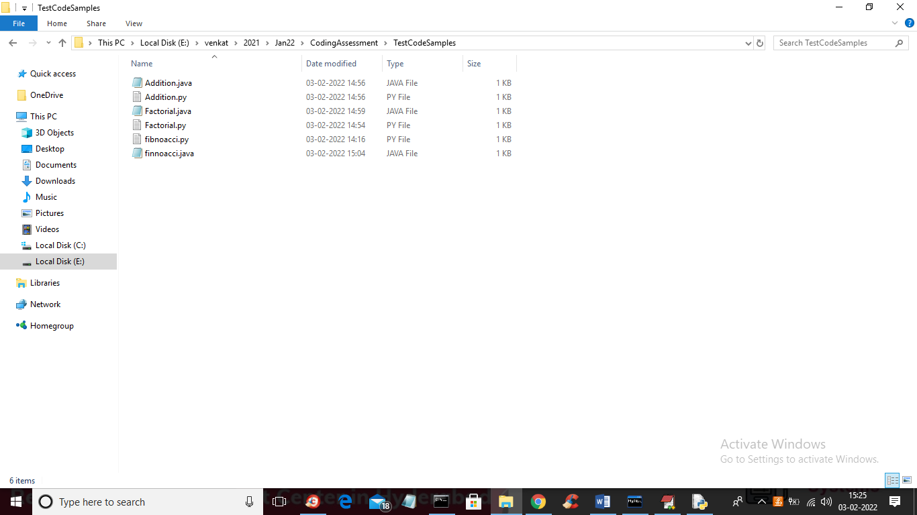

SCREEN SHOTS

To run project install PYTHON 3.7 and MYSQL and then copy content from DB.txt file and then paste in MYSQL to create database

Now double click on ‘run.bat’ to start DJANGO server and to get below screen

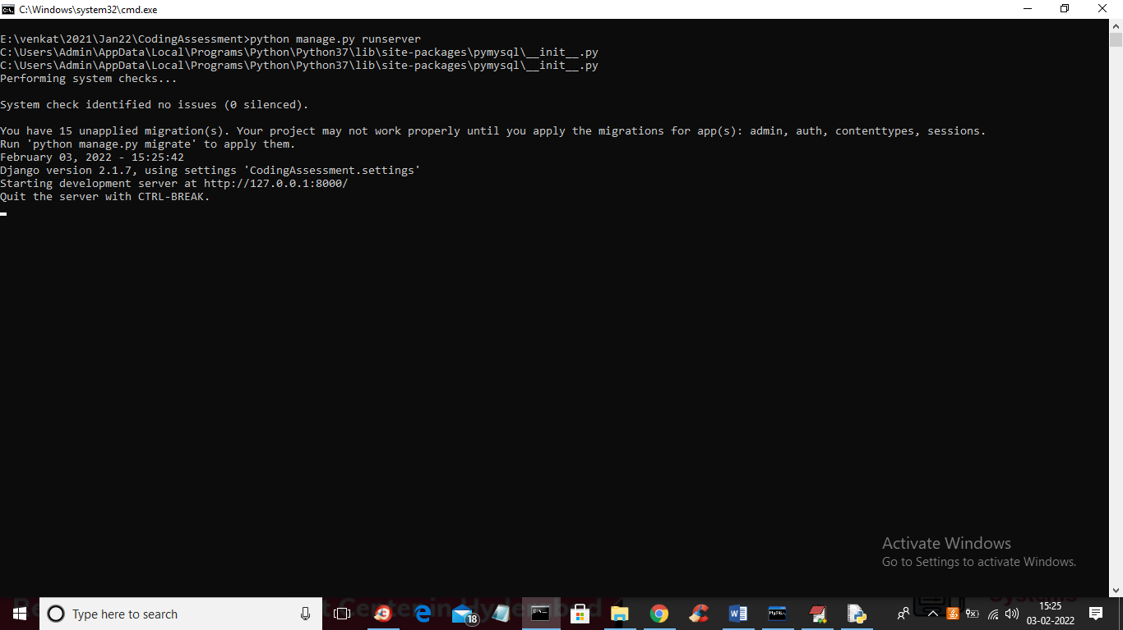

In above screen DJANGO server started and now open browser and enter URL as <http://127.0.0.1:8000/index.html> and press enter key to get below page

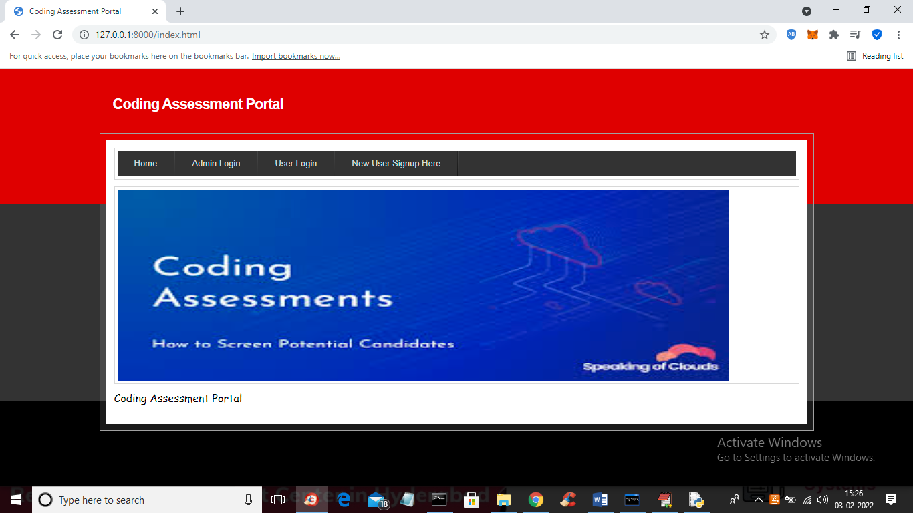

In above screen click on ‘New User Signup Here’ link to add new user and to get below screen

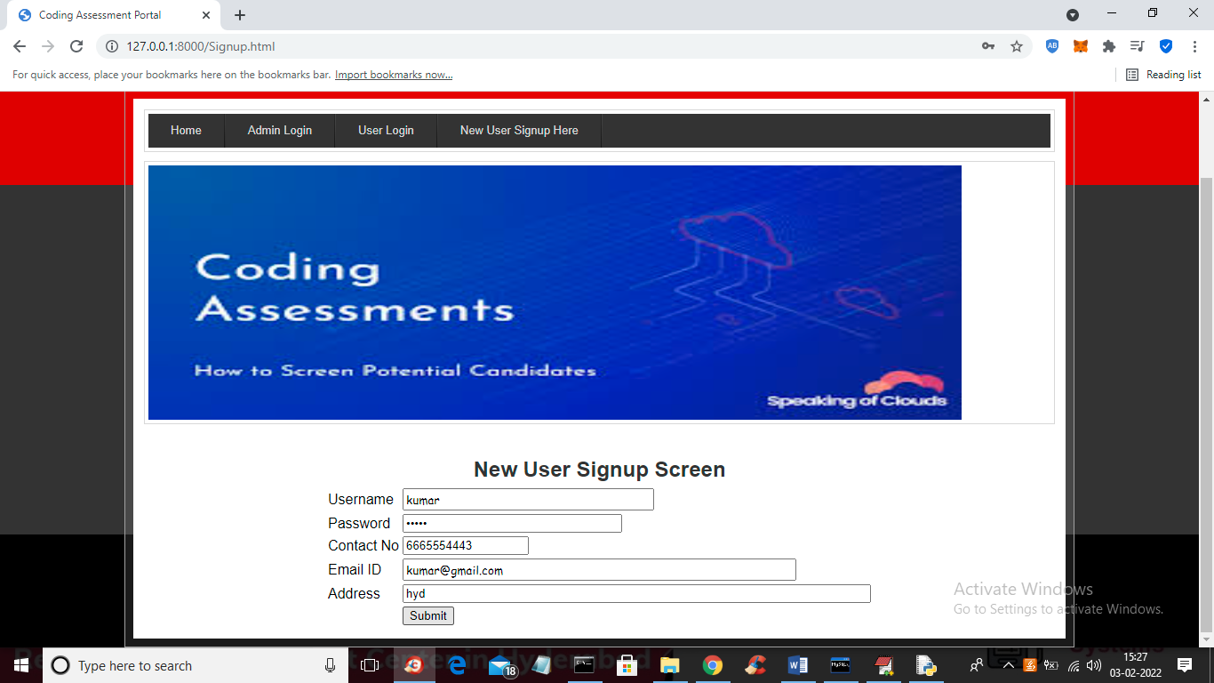

In above screen user is entering signup details and then press ‘Submit’ button to get below screen

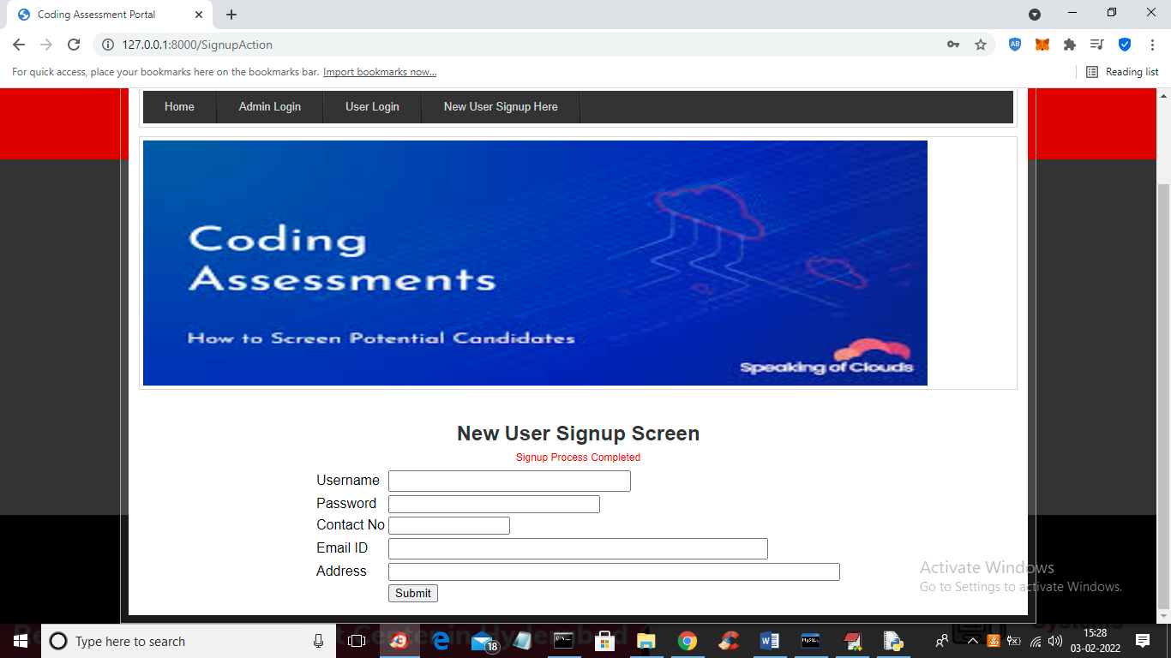

In above screen in red colour text we can see signup process completed and now click on ‘Admin Login’ link to get below screen

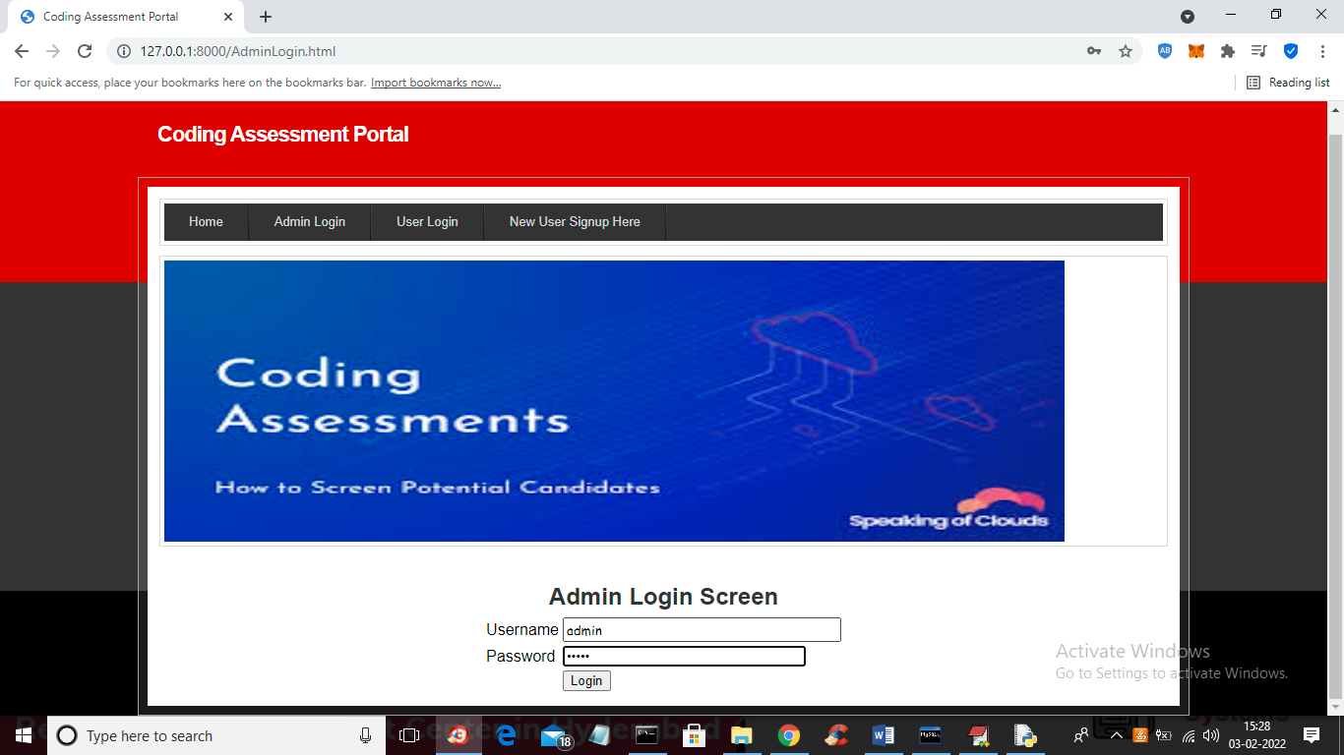

In above screen admin is login and after login will get below screen

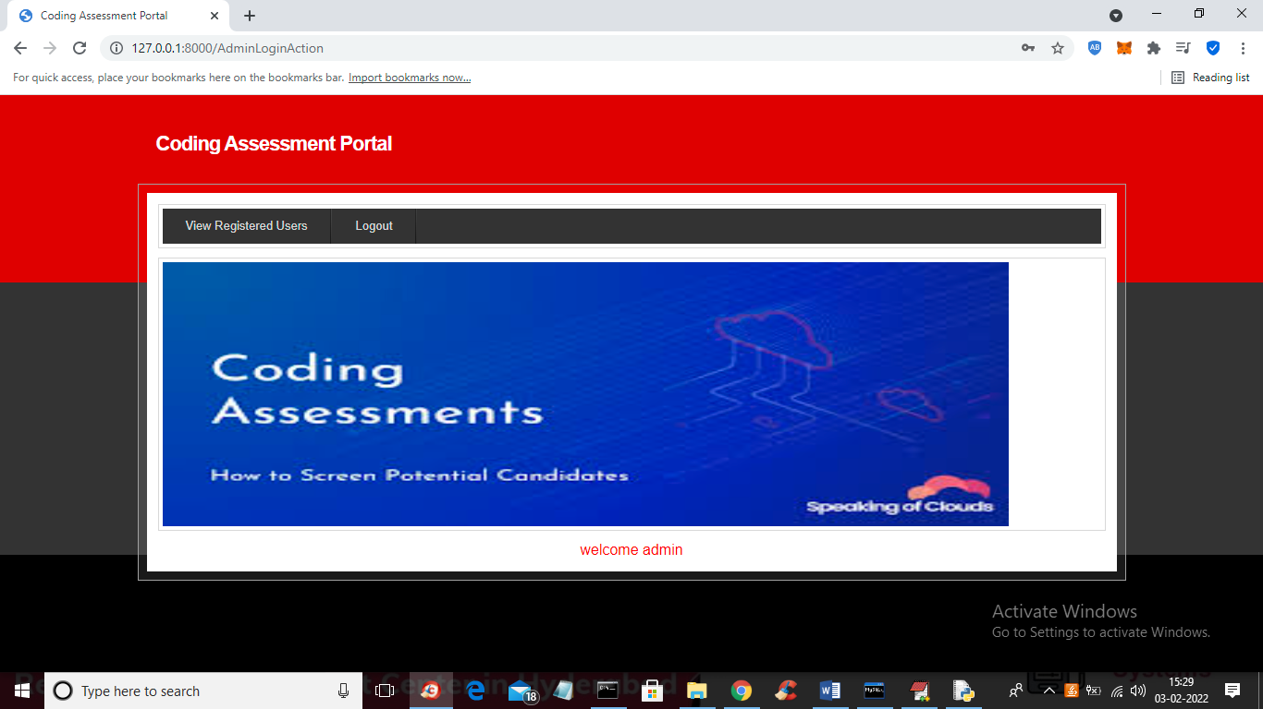

In above screen admin can click on ‘View Registered Users’ link to get below output

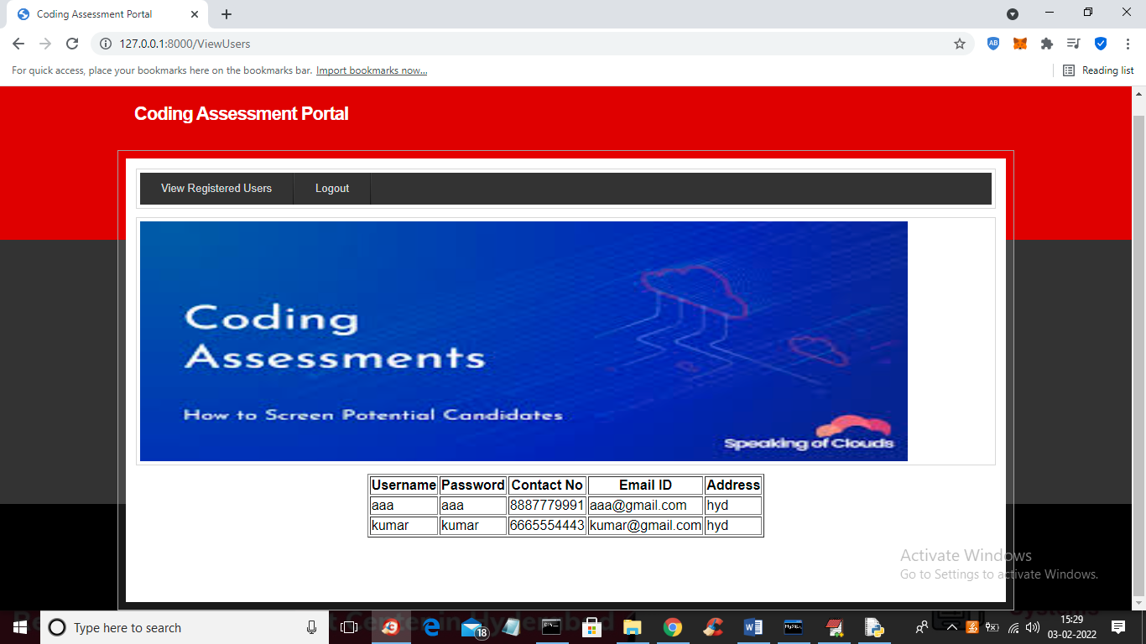

In above screen admin can view all registered user details and now logout and login as kumar user

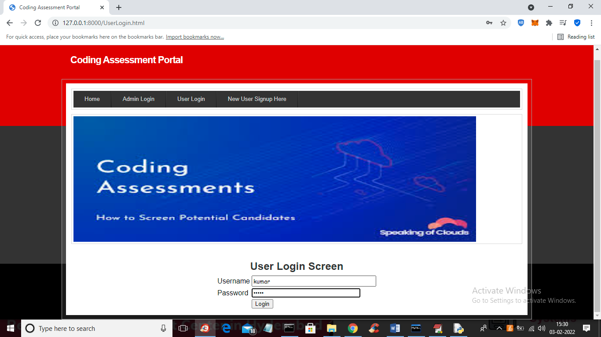

In above screen user is login and after login will get below screen

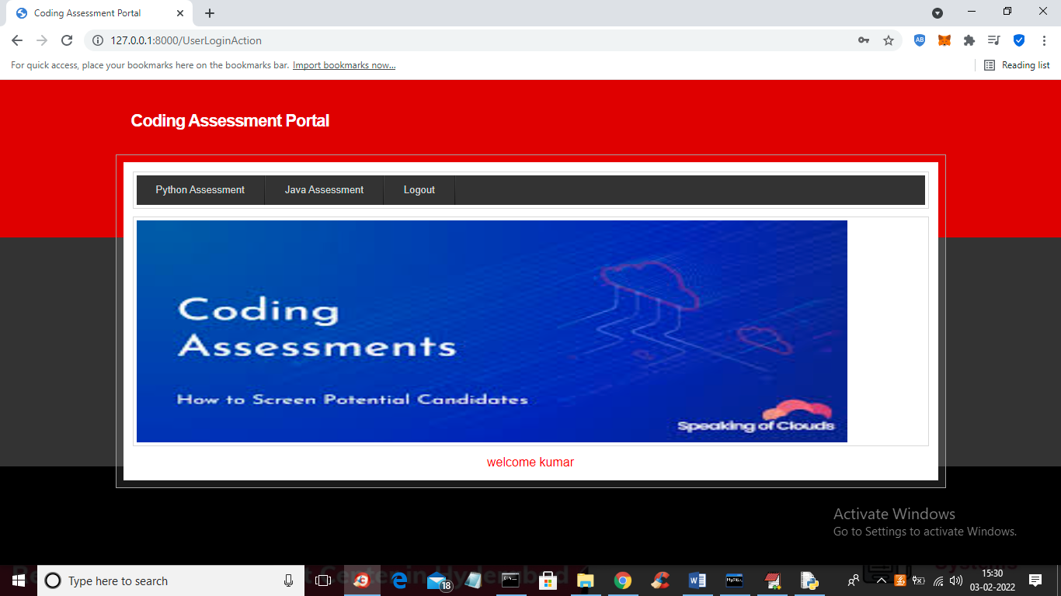

In above screen user can click on ‘Python Assessment’ link to get below screen

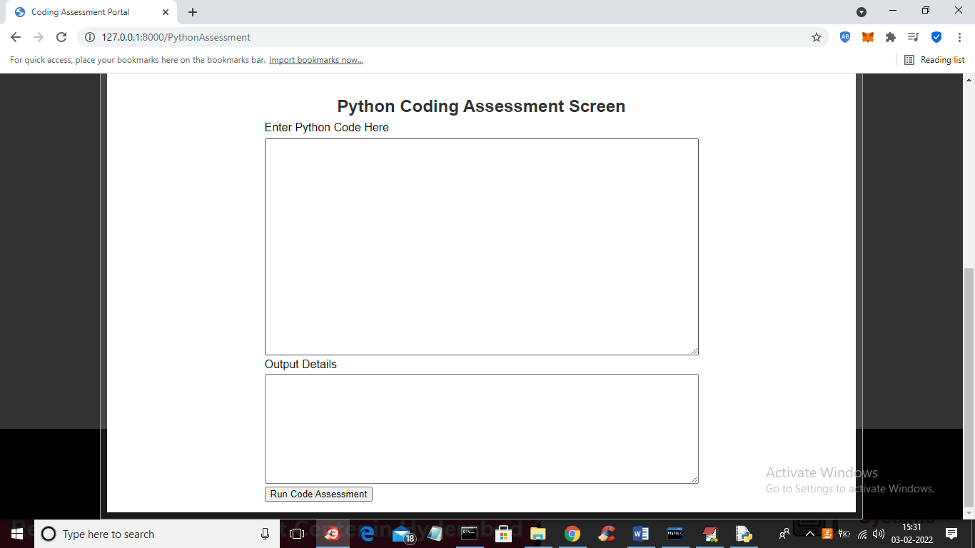

In above screen in first text area you can enter python code and in second text area you can see output

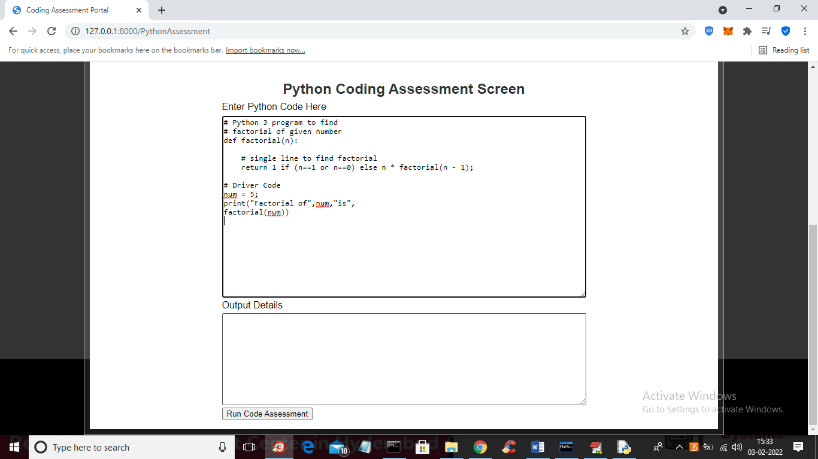

In above screen I entered some factorial program and now press ‘Run Code Assessment’ button to get below output

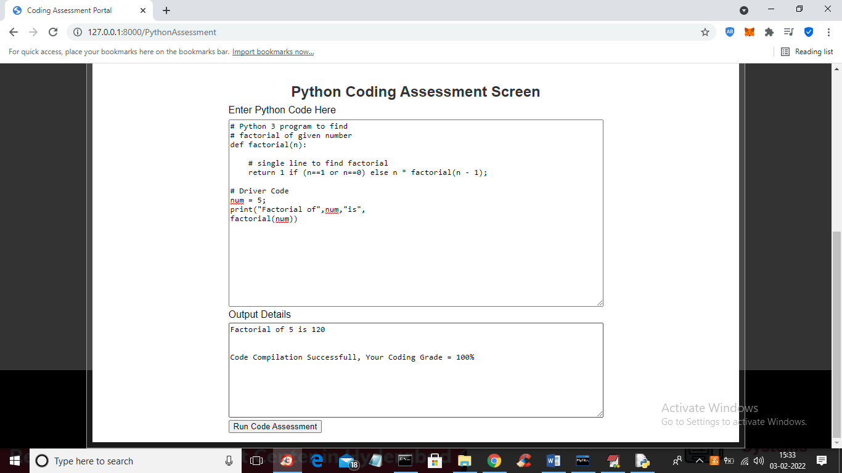

In above screen in second text area we got output as ‘Factorial of 5 is 120’ and we got message as Code Compilation Successful and got grade as 100% and now put some error in code and then execute again

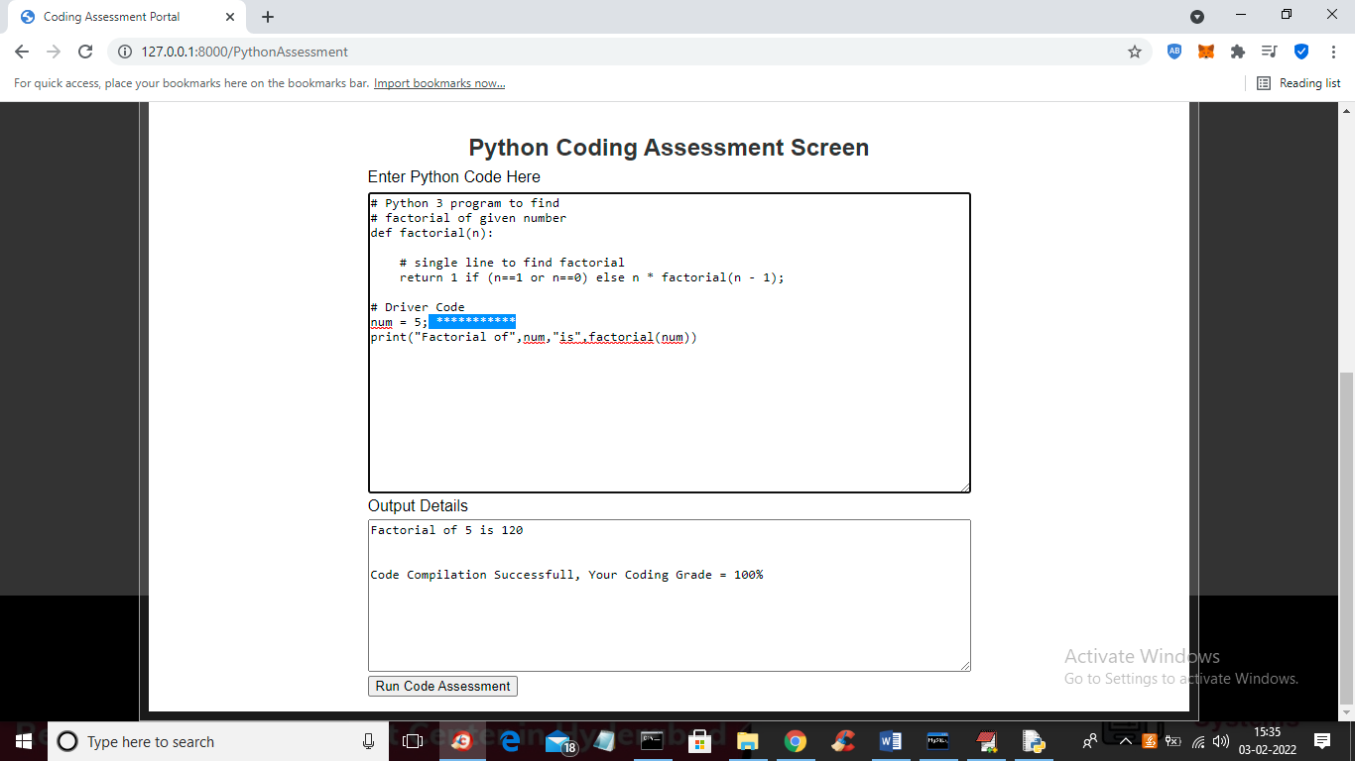

In above screen in blue colour text you can see I added some garbage \* symbols which are not valid and press button to get below compilation error

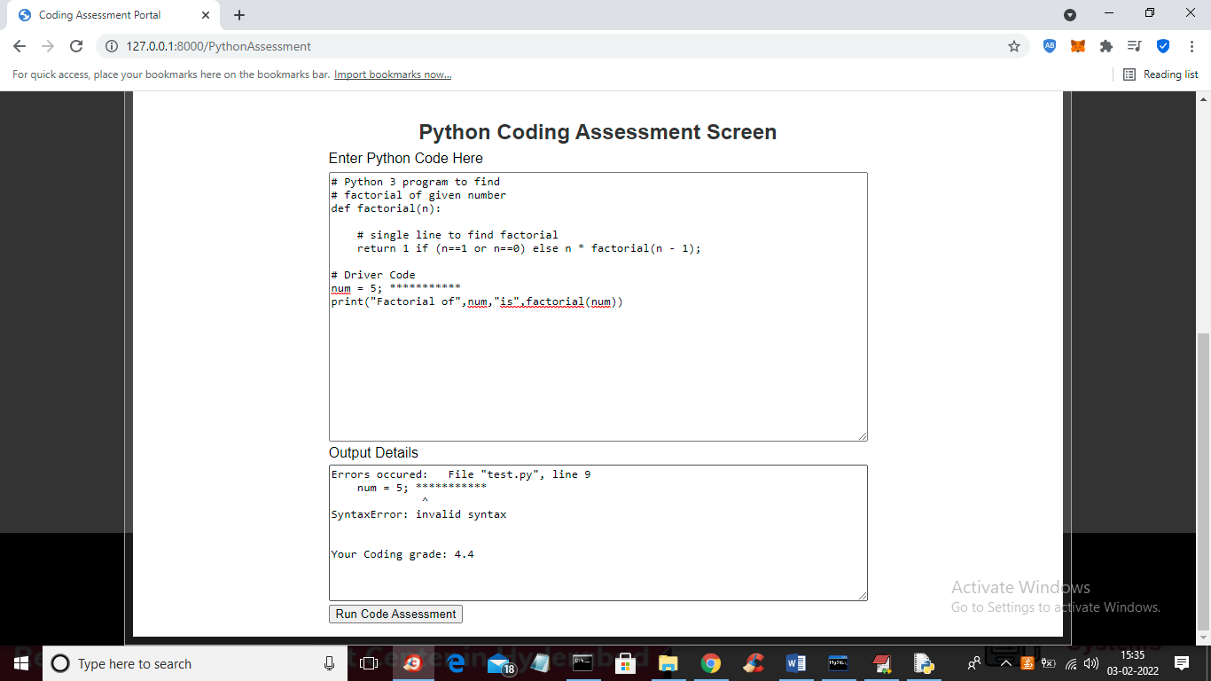

In above screen in second text area we got error details and we got grade as 4.4% and similarly you can test other programs also. Now click on ‘Java Assessment’ link to get below screen

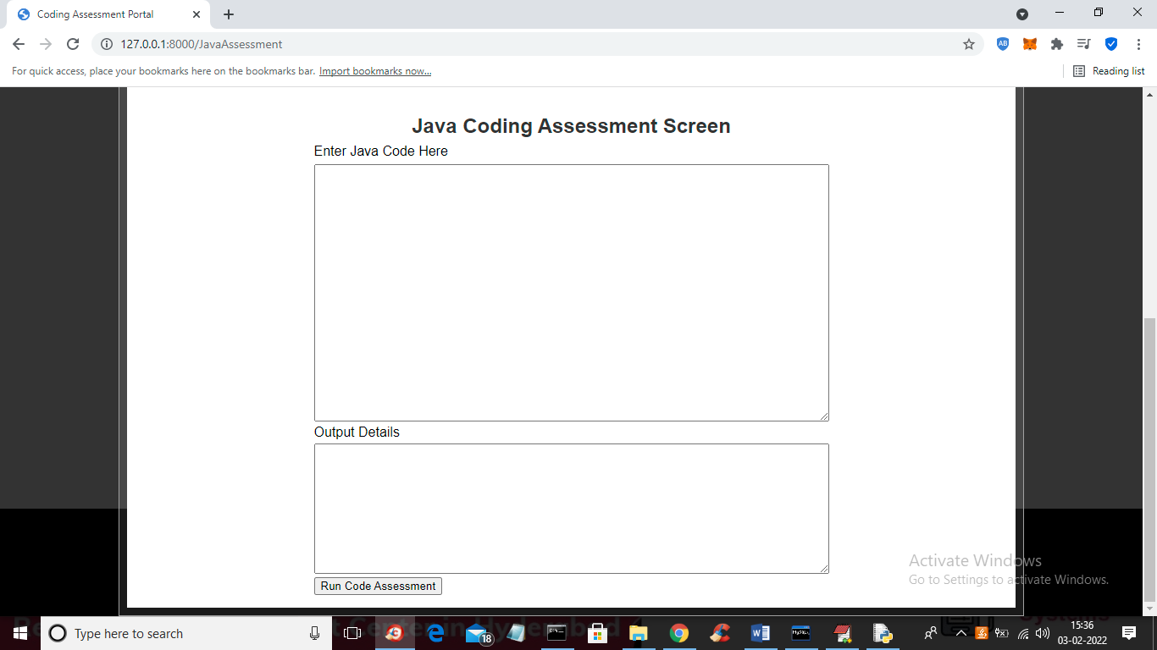

In above screen in first text area you can enter java program and in second text area u will see error or output details

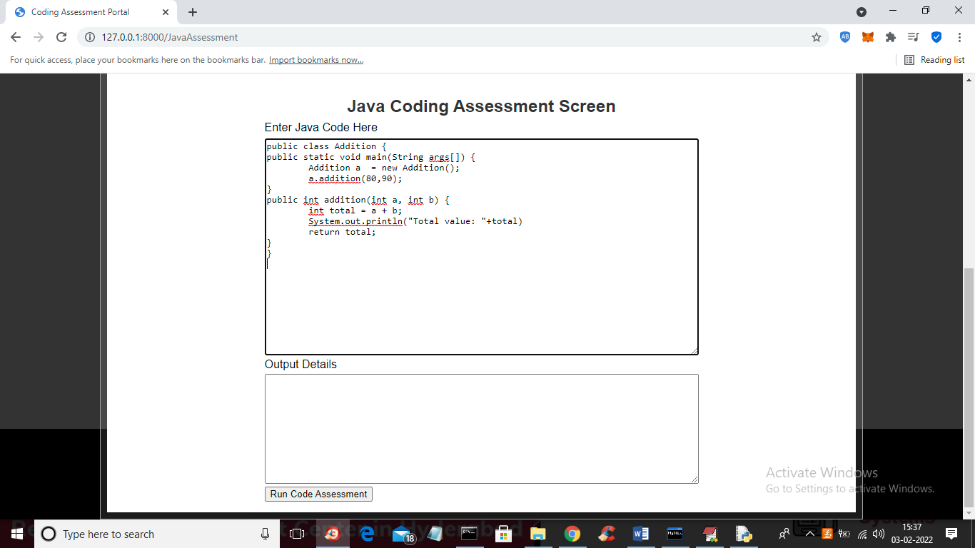

In above screen I entered some addition of 2 numbers program and press button to get below output

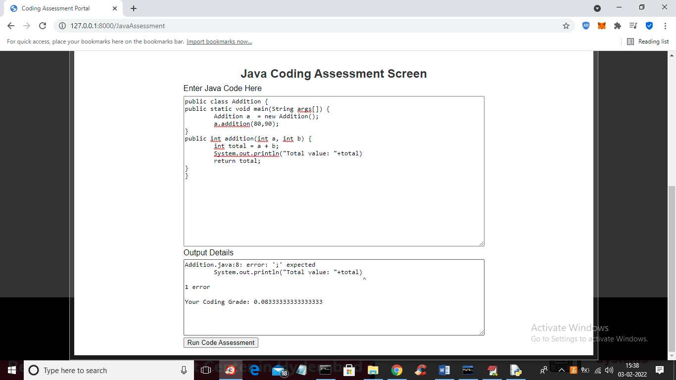

In above screen I got error as I forgot to put ‘;’ after System.out. statement and now I will run same program after putting semicolon

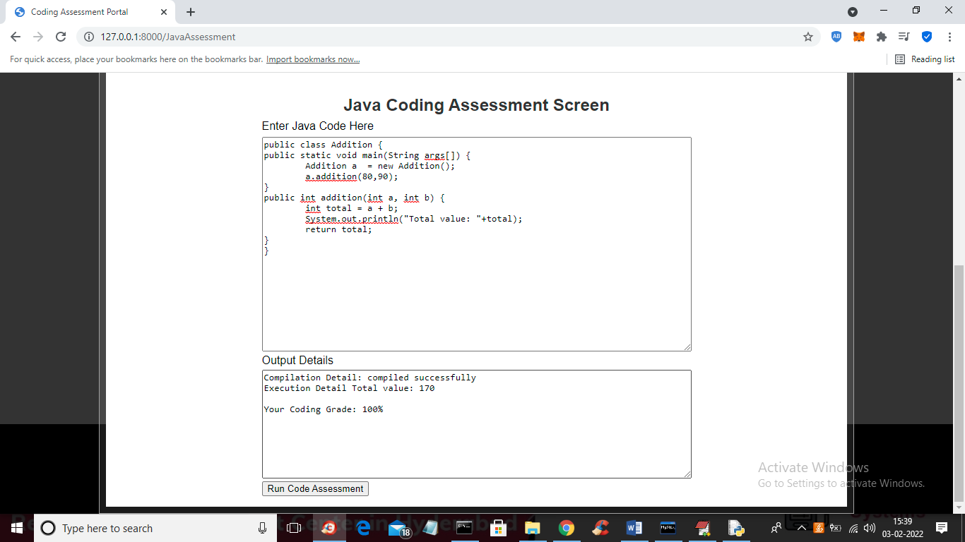

In above screen program got compiled and got addition output as 170 and got grade as 100% as program compiled successfully